**ARUSHA TECHNICAL COLLEGE**



**DEPARTMENT OF ELECTRICAL ENGINEERING**

**DIPLOMA IN ELECTRICAL ENGINEERING**

**(NTA LEVEL 6)**

PROJECT TITLE **: INTELLIGENCE PASSWORD BASED CIRCUIT BREAKER WITH WEB SERVER**

PROJECT TYPE : **PROBLEM SOLVING**

STUDENT’S NAME **: JUMA YUNUS MHANDO**

ADMISSION NO **: 22030712118**

ACADEMIC YEAR **: 2022/2023**

**DECLARATION**

I declare that this report and work described in it, it’s my work, with contribution from others as acknowledged below. I also declare that this work fulfils the requirements for Diploma in Electrical Engineering, and has been done in accordance with the regulations of the Arusha technical.

Signature………………………Date…………………..

Name:JUMA YUNUS MHANDO

Admission number: 22030712118

Supervisor’s Signature………………………….. Date……………………………

**ACKNOWLEDGEMENT**

In course of preparing this project report, I would like to express my sincere appreciations to all those who assisted me during the time of this study. Without them I would not have been successful in completing it. I would like to thank all of them.

Firstly I would like to thank my, **H.O.D, Mr**. **Ally Ngulugulu** for providing me all the facilities needed for my Project.

Secondly, I also thank my project coordinator, **Mr. Daniel Mayala,** for his support, motivation constructive advice, guidance and giving me ideas to develop and complete my project.

Thirdly, I would like to express my deepest feeling of gratitude and genuine appreciation to my Project supervisor**, Mr.Crecent B. Sembuli**, for his direction and support in my work. I have discovered him very helpful while examining the various issues in this project. His critical remarks on my work have surely made me consider new thoughts and procedures.

Fourthly, I want to appreciate my Father **William saliel Mariki** for his continues support, encouragement, inspiration and prayers throughout my studies, And I would like also to thank Arusha Technical College, for providing me this opportunity to do this project and write this paper as a part of my project report.

Lastly, I would like to trustfully and thankful to my dearest wife **Ms.Rehema peter Ngowi** for her unconditionally and unlimited support, prayers and loyalty to me since I was admitted at Arusha Technical College including her great contribution in my entire project completion.

**ABSTRACT**

In now days switches and fuses are used to control , but there are disadvantages for using them , for example when a fuse blows out it takes a quite sometimes to replace,also a fuse cannot interrupt the heavy fault current , we can conclude that the fuses and switches are limited to low voltage and small capacity circuits. With advancement of power system the lines and equipment operate at very high voltage and carry a large currents this necessitates to employ a more dependable means of control such as it obtained by use of circuit breakers.

Circuit breakers are electrical devices which break electrical power system either manually or automatically at normal or abnormal automatically. Tanesco substations uses circuit breaker in both conditions to turn ON or OFF the power line. The approach the have been used is not the secure since the breaker can be operated by any operator.

In this paper, it is intended to improvise these standards by employing new design techniques and developing an INTELLIGENCE PASSWORD BASED CIRCUIT BREAKER WITH WEB SERVER that will ensure safety. This paper deals with the design of a building password based circuit breaker using an ESP32 controller. The system is fully controlled by the ESP32 microcontroller, the user/operator will be required to create his own password with the help of keypad or by using telephone through a web server and a display. After entering the password is saved and be used to turn ON or OFF the circuit breaker.

Keywords: ESP 32,Web server, keypad, display.

# LIST OF ABBREVIATIONS

A-Amperes

CB-circuit breaker

IC-intergrated circuit

kV-kilovolts

LCD-liquid crystal display

Contents

DECLARATION i

ABSTRACT ii

ACKNOWLEDGEMENT iii

ABBREVIATIONS vi

LIST OF FIGURES vii

CHAPTER ONE 1

INTRODUCTION 1

1.1 INTRODUCTION 1

1.2 PROBLEM STATEMENT 1

1.3 PROJECT SCOPE 2

1.4 PROJECT OBJECTIVES 2

1.4.1 Main objective 2

1.4.2 Specific objectives 2

1.5 Significance of the project 2

CHAPTER TWO 3

LITERATURE REVIEW 3

2.1 INTRODUCTION 3

2.2 Introduction to circuit breakers 3

2.2.1 Operating principle 3

2.3 Types of Circuit Breakers 4

2.3.1 Air circuit breaker 4

2.3.2 SF6 and vacuum circuit breakers 6

2.3.3 Vacuum circuit breaker 8

2.3.4 Oil circuit breakers 9

2.4 Existing system 10

2.4.1 Advantages of existing system 10

2.4.2 Disadvantages of existing system 10

2.5 Proposed system 11

2.6 Block diagram description 12

2.6.1 Microcontroller 12

2.6.2 Liquid Crystal Display 12

2.6.3 Relay 12

2.6.4 Keypad 12

2.7 Advantages of the proposed system 12

2.7.1 Disadvantages of the proposed system 13

CHAPTER THREE 14

METHODOLOGY 14

3.1 Introduction 14

3.2 Consultation 14

3.3 Literature review 14

3.4 Data collection 14

3.5 Data analysis 14

3.6 Simulation. 15

3.7 Designing the circuit. 15

3.8 Construction and testing of a prototype. 15

3.9 Project report writing. 15

REFERENCES 16

# LIST OF FIGURES

figure 2. 1 Air circuit breaker switchgear 5

figure 2. 2 External form of air circuit breaker 6

figure 2. 3 SF6 circuit breaker 7

figure 2. 4 Vacuum circuit breaker 8

figure 2. 5 Oil circuit breaker 9

Figure 2.6 Block diagram of existing system 10

Figure 2. 7 Block diagram of proposed system 11

CHAPTER ONE

INTRODUCTION

* 1. INTRODUCTION

Tanzania Electric Supply Company Limited (Tanesco), substation facilities normally use circuit breaker system to open or close the circuit when an error arises in the system. It includes two moving parts that are usually closed. When an error happens in the system, then the relay transmits the signal to the circuit-breaker & therefore their parts are moved separately. Therefore, errors occur in the system turns into clear. These breaker are used to turn off a certain part of the power system and it is done by an operator. The current switching mechanism is not more secure because once an operator turn OFF the breaker any other operator can turn ON the breaker which may result to a very serious problem to the user.

This project is intended to design a system that will ensure a secured circuit breaker operation whereby a substation operator will be required to create a unique password and use it to open and close the breaker circuit. This will ensure security and safety at work.

* 1. PROBLEM STATEMENT

To give safe environment to the electrical and mechanical maintenance staff team about no one can return the circuit breaker unless he get finished his work I intend to design a circuit breaker based with password to achieve a safely system to the team that work on maintenance whatever it is. A circuit breaker is an automatically operated electrical switch designed to protect an electrical circuit from damage caused by overload or short circuit. Its basic function is to detect a fault condition and interrupt current flow. Unlike a fuse, which operates once and then must be reset (either manually or automatically) to resume normal operation. When operate manually we see fatal electrical accidents to the workers and technical staffs are increasing during the electrical and mechanical plant repair due to the lack of communication and coordination between the maintenance staff and the MCC.

* 1. PROJECT SCOPE

The system will be used and offer protection for over current, short circuit faults and safety condition of the workers during maintananance and other activities through password.

### 1.4 PROJECT OBJECTIVES

The following are the project objectives

### 1.4.1 Main objective

The aim of this project is to design an INTELLIGENCE PASSWORD BASED CIRCUIT BREAKER WITH WEB SERVER.

### 1.4.2 Specific objectives

The following are the specific objectives that will be taken to achieve the main objective.

* To design a circuit diagram of the project.
* Interfacing the components using a microcontroller.
* Simulation of the circuit.
* Collection of the components and testing if it function properly.
* Implementation of the prototype and testing.

.

* 1. Significance of the project
* Avoids electrical accidents to electrician and other maintenance staff team.
* It is effective on providing safety on working staff.
* It can be easily installed.
* Fulfilment required for my award of bachelor in Electrical and Automation Engineering.

CHAPTER TWO

LITERATURE REVIEW

2.1 INTRODUCTION

This chapter concentrates on describing the features, block diagrams, operations of the existing and proposed system. In this case, materials have been reviewed so as to obtain advantage and disadvantages of the existing and proposed systems. This review will help us to understand the scope of the project. The review comes from the reading on the websites, documentations and from books.

## 2.2 Introduction to circuit breakers

As a matter of fact the power system is necessary to control switch on or off whatever it was at normal condition or abnormal condition at various circuits like (transmission lines, distributors, generating plants). In now days switches and fuses were used to control , but there are disadvantages for using them , for example when a fuse blows out it takes a quite sometimes to replace,also a fuse cannot interrupt the heavy fault current , we can conclude that the fuses and switches are limited to low voltage and small capacity circuits. With advancement of power system the lines and equipment operate at very high voltage and carry a large currents this necessitates to employ a more dependable means of control such as it obtained by use of circuit breakers.

A circuit breaker is an electrical equipment which can make or break the circuit either manually or automatically under all conditions no-load , full-load , short circuit this made circuit breaker very useful in switching or protection of various parts of the power system.

### 2.2.1 Operating principle

A circuit breaker essentially consists of fixed and moving contacts, called electrodes. These contacts remain closed and will not open automatically until and unless the system becomes faulty. Of course, the contacts can be opened manually or by remote control whenever desired.

When a fault occurs on any part of the system, the trip coils of the circuit breaker get energised and the moving contacts are pulled apart by some mechanism, thus opening the circuit. When the contacts of a circuit breaker are separated under fault conditions, an arc is struck between them. The production of arc not only delays the current interruption process but it also generates enormous heat which may cause damage the system or to the circuit breaker itself. Therefore extinguish the arc within the shortest possible time so that heat generated by it may not reach a dangerous value.

There are two methods of extinguishing the arc in circuit breakers the high resistance method and the low resistance or current zero method.

High resistance method: Arc resistance is made to increase with time so that current is reduced to a value insufficient to maintain the arc .the disadvantage of this method is that enormous energy is dissipated in the arc. Therefore, it is employed only in D.C circuit breakers and low-capacity A.C circuit breakers.

Low resistance or current zero method: This method is employed for arc extinction in A.C circuits only. It has small dielectric strength and can be easily broken down by the rising contact voltage.

## 2.3 Types of Circuit Breakers

The types of breakers basically refer to the medium in which the breaker opens and closes. The medium could be oil, air, vacuum and SF6.

### 2.3.1 Air circuit breaker

Interrupting contacts situated in air instead of any other artificial medium. Arc is chopped into a number of small arcs by the Arc-Shute as it rises due to heat and magnetic forces. The air circuit breakers are normally employed for 380~V.

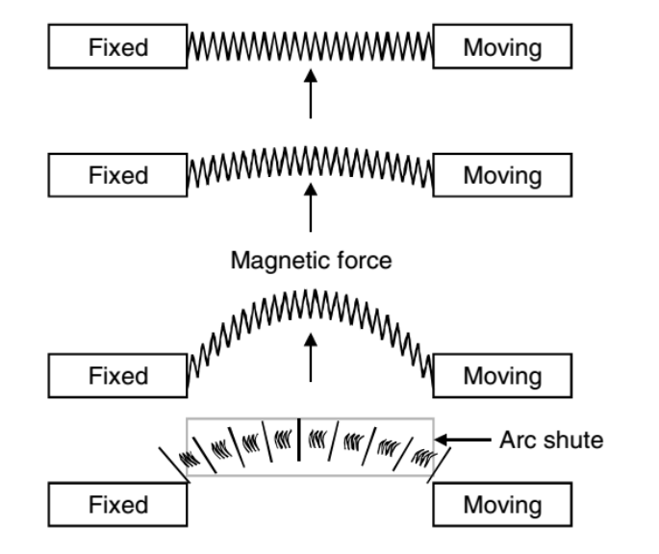

figure 2. 1 Air circuit breaker switchgear

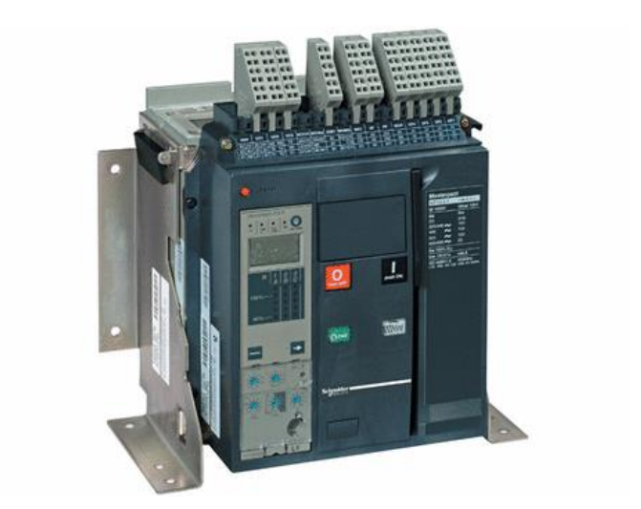

figure 2. 2 External form of air circuit breaker

### 2.3.2 SF6 and vacuum circuit breakers

Sulphur-hexafluoride SF6 is an inert insulating gas, which is becoming increasingly popular in modern switchgear designs both as an insulating as well as an arc-quenching medium. Gas insulated switchgear GIS is a combination of breaker, isolator, CT, PT, etc., and are used to replace outdoor substations operating at the higher voltage levels, namely 66 kV and above For medium- and low-voltage installations, the SF6 circuit breaker remains constructional the same as that for oil and air circuit breakers mentioned above, except for the arc interrupting chamber which is of a special design, filled with SF6.To interrupt an arc drawn when contacts of the circuit breaker separate, a gas flow is required to cool the arcing zone at current interruption i.e. current zero. This can be achieved by a gas flow generated with a piston known as the ‘puffer’ principle, or by heating the gas of constant volume with the arc’s energy. The resulting gas expansion is directed through nozzles to provide the required gas flow.

The pressure of the SF6 gas is generally maintained above atmospheric; so good sealing of the gas chambers is vitally important. Leaks will cause loss of insulating medium and clearances are not designed for use in air.

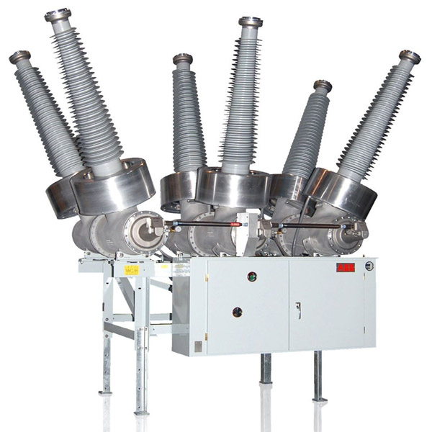

figure 2. 3 SF6 circuit breaker

### 2.3.3 Vacuum circuit breaker

A vacuum circuit breaker is a kind of circuit breaker where the arc quenching takes place in a vacuum medium. The operation of switching on and closing of current carrying contacts and interrelated arc interruption takes place in a vacuum chamber in the breaker which is called a vacuum interrupter. Since vacuum offers the highest insulating strength, it has far superior arc quenching properties than any other medium. For example, when contacts of a breaker are opened in vacuum, the interruption occurs at first current zero with dielectric strength between the contacts building up at a rate thousands of times higher than that obtained with other circuit breakers.

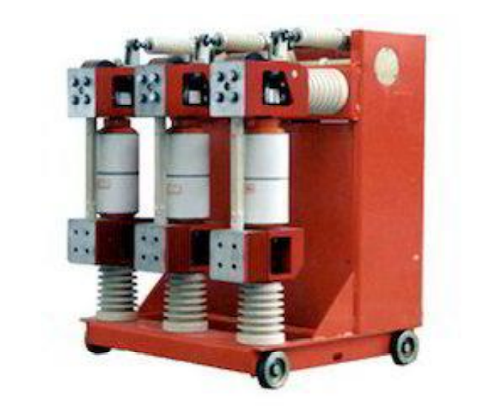

figure 2. 4 Vacuum circuit breaker

### 2.3.4 Oil circuit breakers

In this circuit breaker we use some insulating oil just as transformer oil the heat of the arc evaporates the surrounding oil and dissociates it into a substantial volume of gaseous hydrogen at high pressure .The hydrogen gas occupies a volume about one thousand times that of the oil decomposed. The oil is, therefore, pushed away from the arc and an expanding hydrogen gas bubble surrounds the arc region and adjacent portions of the contacts. The arc extinction is facilitated mainly by two processes: Firstly, the hydrogen gas has high heat conductivity and cools the arc, thus aiding the de-ionisation of the medium between the contacts. Secondly, the gas sets up turbulence in the oil and forces it into the space between contacts, thus eliminating the arcing products from the arc path.

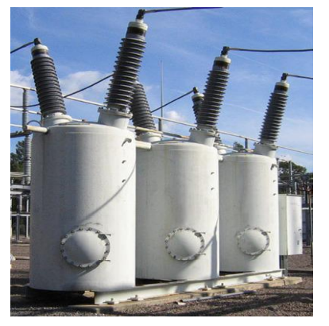

figure 2. 5 Oil circuit breaker

## 2.4 Existing system

The existing system the circuit breakers are connected direct with the busbars from the supply line to the transmission line.

POWER SUPPLY

BARS BAR

FUSED ISOLATOR

CIRCUIT BREAKERS

LOADS

Figure 2.6 Block diagram of existing system

### 2.4.1 Advantages of existing system

* The system is compact, reliable and have longer life.
* No fire Hazard
* They can interrupt any fault current.6
* Require less power for control operation.
* It has higher dielectric strength

### 2.4.2 Disadvantages of existing system

* Loss of vacuum due to transit damage or failure makes the entire interruption useless and it cannot be repaired in site.
* It need additional surge suppression in parallel with each phase for interruption of low magnetizing currents in certain range.
* Since the contact structure of the vacuum circuit breaker adopts the butt connection type, and the operating mechanism uses a spring, it is easy to produce closing bounce and opening rebound. Closing bounce will not only produce high overvoltage’s that affect the stable operation of the power grid, but also cause contact burnout or even welding, especially when the capacitor bank is used to generate inrush current and short-circuit closing.

## 2.5 Proposed system

Password Based Circuit Breaker is a simple in construction, it is a project that helps in controlling the electrical lines with the help of a password. The system will consist of micro controller, 4x4 keypad, LCD display, Relay and Buzzer. A matrix keypad is connected to the microcontroller to enter the password. The entered password is compared with the stored password in the ROM of the microcontroller. If the given password is right, then the line can be switched ON/OFF followed by the buzzer sound to provide the confirmation of user input and providing attention environment.

AC SUPPLY

BRIDGERECTFIER

TRANSFORMER

VOLTAGE REGULATOR

MICRO

CONTROLLER

RELAY DRIVER IC

LCD DISPLAY

BUZZER

KEYPAD

LOADS

Figure 2. 7 Block diagram of proposed system

## 2.6 Block diagram description

### 2.6.1 Microcontroller

Microcontroller is small computer on a single integrated circuit containing a processor, memory, and programmable input/output peripherals. Neither program memory in the form of NOR flash or OTP ROM is also often included on chip as well as a typically small amount of RAM. Microcontrollers are designed for embedded applications, in contrast to the microprocessors used in personal computers or other general-purpose applications.

### 2.6.2 Liquid Crystal Display

For ease of interaction with the user, this system uses an electronic display module. This means in two lines it is possible to display 16 characters per line. Two registers are associated with an LCD, such as data and command. These modules are preferred since it is easily programmable. For providing visual assistance to the lineman this module is unavoidable.

### 2.6.3 Relay

A relay an electromagnetic device which is used to isolate two circuits electrically and connect them magnetically. They are very usefully device and allow one circuit to switch another one while they are completed separated. The required current to run the relay coil is more than can be supplied by various integrated circuits like operation amplifier, etc.

### 2.6.4 Keypad

4*4 keypad Used to enter password when we want to operate the system. It is matrix contain rows and columns of switches.

## 2.7 Advantages of the proposed system

* It avoids electrical and mechanical accidents to workers and maintenance team.
* This project is very simple and easy in construction and implementation.
* It can be built with commonly available components.
* It give no scope of password stealing
* It is effective on providing safety on working staff.
* It can be easily installed.

### 2.7.1 Disadvantages of the proposed system

* After installation the maintenance cost is increased.
* Programming of this system is too large and complicated.
* By forgetting the password, it becomes difficult to operate the system.

CHAPTER THREE

## METHODOLOGY

## 3.1 Introduction

This chapter describes different steps that will be taken in order to accomplish the design of password based circuit breaker with alarm system alert. To ensure the project prototype successfully developed, some tasks must be performed by following different sequence of work as follows;

## 3.2 Consultation

Consultation with my supervisor will be of vital importance in order to get the guidance, advice, corrections, and even encouragement. Other lecturers and qualified professionals will help me to achieve the objective due to their assistance based on their experience and professionals.

## 3.3 Literature review

This method involving passing through different sources of information in a particular area of a subject and will explore the existing system with their advantages and limitations as well as the proposed system. Sources of information to be used are; books, journals and various research.

## 3.4 Data collection

This involves gathering different information that will assist in designing the system. The data should help in analysing the information and fabrication of the prototype.

## 3.5 Data analysis

It will involve manipulation of data collected and a clear understanding of different techniques that will be used in this project so as to have technical reasons for the selection of technology and device to be used in this project.

## 3.6 Simulation.

Different parts of this system after design will be simulated in order to observe the results of each part before implementing the complete circuit.

## 3.7 Designing the circuit.

This involves the process of working out the physical form that an electronic circuit will take.

## 3.8 Construction and testing of a prototype.

Afterdesigning the circuit the construction of the prototype is done and also that prototype will be tested to see if is working as it is intended to.

## 3.9 Project report writing.

Finalizing by writing the project report for submission after testing the prototype.

CHAPTER FOUR

DATA COLLECTION

**4.1 Introduction**

This chapter provides the data collected from different sources which reveal the existence of the need. Data collected act as a guide towards designing of the proper password based circuit breaker. The data were collected from different sources including reading literature, site visitation, observation and interview from experienced person.

**4.2 Primary data**

The primary data is the key data to the system design, for our case the load rating is the key data.

The below table shows the maximum and minimum rating for substation circuit breakers especially for 11kV and 33Kv.

Table 4.1: Circuit breaker rating

|  |  |  |
| --- | --- | --- |
| Type | Load current | Voltage |
| Maximum | 2500A | 11kV – 33kV |
| Minimum | 400A | 11kV – 33kV |

In our design it is indended to design only trigerring mechanim so to domenstrate the system operation the system will only include home appliances as examples.

Load ratings to be used as examples

|  |  |  |
| --- | --- | --- |
| Type | Power rating | System Voltage |
| Appliance | 300W | 220V |

**4.3 Secondary data**

These are the data collected based on the literature reviewed. Since the units of the system are already being proposed the data about their ratings are collected so that to give an intuition of the system’s components to be used.

**4.3.1 System units power ratings**

The system to be designed consists of different units with different power ratings. Before the components of the system are interfaced together the information about their source voltages and input current are gathered to ensure the correct selection of the component.

The data about individual components are shown in the table below.

Table 4.3: system units power ratings

|  |  |  |
| --- | --- | --- |
| Unit | Supply Voltage | Input Current |
| Control unit | 4.4 ~ 5Vdc | 400mA ~ above |
| Display module | 4.5~ 5Vdc | 150mA |
| Switching device | 5~ 12Vdc | 20mA~70mA |

**4.3.3 Control units available**

The system includes a controller which will be controlling the input and output modules. For the system to a reliable and more efficient the most efficient and reliable control unit should be selected. The table below shows different controllers that may suit the system designing with their distinctive features and key parameters.

Table 4.5: control units and their technical characteristics

|  |  |  |  |  |
| --- | --- | --- | --- | --- |
| Specifications | AT89S52 | PIC16690 | ATmega16 | ATmega328P |
| I/O pins | 32 | 18 | 32 | 28 |
| Operating voltage (V) | 4.0-5.5 | 4.0-5.5 | 4.0-5.5 | 4.0-5.5 |
| Operating Frequency | 33MHz | 20MHz | 16MHz | 16MHz |
| Architecture | RISC | RISC | RISC | RISC |

CHAPTER FIVE

DATA ANALYSIS

**5.1 Switching unit selection**

The switch of the system to be designed has to be able switch 300W/220V appliances.

Current consumption calculation

Power formular

P = V × I × cos(θ)

I = P/ V × cos(θ)

I = P/ V × cos(θ)

I = 300/220 × 0.8

I = 1.7

Therefore heater current is approximtly 2A

In this system, 5V relay will be used as a switching device since it meets the load requirement in terms of voltage and current ratings.

Table 5.1: Relay specifications

|  |  |
| --- | --- |
| Parameters | Values |
| Operating Voltage | 5V |
| The static current | 2mA |
| Working current | ~70mA |
| maximum load voltage | 250VAC, 30VDC |
| maximum load current | 10A (for AC and DC load) |

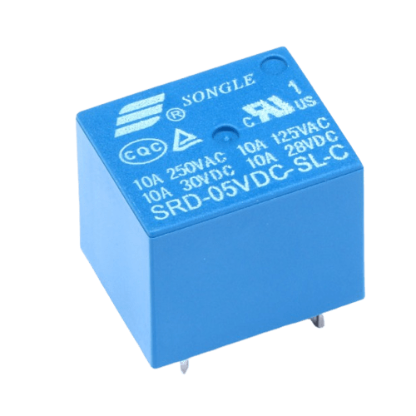

Figure 5.1 Songle 5V relay

**5.2 Control Unit Selection**

Control unit is the sub-system of the proposed system used to control all the actions carried on during operation of the proposed system. There are varieties types of the controllers in the market so qualitative analysis has to be done for good choice of the controller. The control unit should meet the following basic requirements according to the data collected in previous chapter.

1. It should operate with minimum power.
2. It should have flash memory space of 32KB for storage of vibrations of the wall.
3. It should be less expensive.

**5.2.2 Qualitative Analysis of Electrical Controllers**

Varies controllers are designed for controlling different systems that are designed to solve real world problems. **Table 5**:2. compares different electrical controllers and their characteristics. Through this comparison the suitable controller for this project may be chosen based on data collected.

**Table 5.2** Different types of electrical controller and characteristics.

|  |  |  |  |
| --- | --- | --- | --- |
| **Characteristics** | **Microcontroller** | **PLC** | **Microprocessor** |
| **Clock rate (MHz)** | Slow clock rate range 4-20 | Slower clock rate range 1-8 | High clock rate greater than 1000 |
| **Memory** | Inbuilt data& program memory | Externally interfaced | Externally interfaced |
| **Programming** | Small | Large | Very small |
| **I/O peripherals** | Inbuilt digital I/O and Analog | Inbuilt digital I/0 | Externally interfaced |
| **Cost** | Less Expensive | Expensive | Expensive |
| **Tasks** | Control specific and related tasks | Control many tasks | Control many tasks |

According to the following factors the microcontroller is chosen

1. Microcontrollers have inbuilt data and program memory.
2. Microcontrollers are cheap compared to PLC.
3. Microcontrollers control specific or closely related tasks compared to microprocessors.

**5.2.3 Qualitative Analysis of Microcontrollers**

There are varies families of the Microcontrollers in the market based on manufacturers. Table 4:5 below compares different microcontrollers and their characteristics. With this qualitative comparison the appropriate microcontroller for this project can be chosen based on the data collected and basic requirements.

The Atmega 328/P microcontroller is chosen as it meets all mentioned basic requirements of control unit.

For the Atmega 328P to control the system, it needs external oscillator circuit to generate the clock signal. Also, it needs a reset button to reset it when it misbehaves during its operation. The physical appearance of ATmega328/P in DIP and MLF is shown in figure 5.2 below

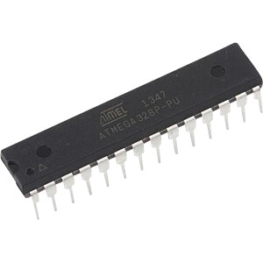

**Figure 5**.2 Physical Appearances of DIP & MLF Atmega 328/P

The pin-out configuration of Dual-in-Line Package (DIP) Atmega 328/P is shown on figure 5.3 below

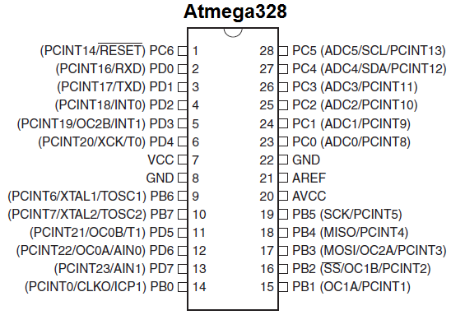

**Figure 5.**3 DIP Atmega 328 Pin Configurations

**5.3 Power Supply unit Selection**

Electronic systems require power supply to perform their intended function. The power supply unit will provide power to other parts of the system such as the switching unit, control unit and the display unit. The required amount of supply will be 5V DC value for digital parts such as the control unit and the LCD display and for relay.

The total current expected is obtained from data collection

Control unit – 400mA

Display Unit – 150mA

Switching unit – 70mA

Total current - 620mA = 0.62A

The system current is appromately 1A

For the power supply to be able to handle the whole system consumption and be stable it should be at least two time the maximum rating which is 2A.

In this design 5V, 5A buck conveter will be used to power the entire system from 12Vdc,3A power adapter.

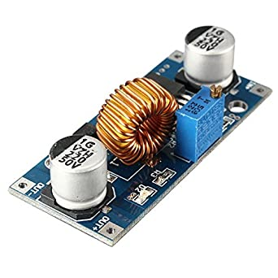

Figure 5.4: XL4015 DC-DC conveter

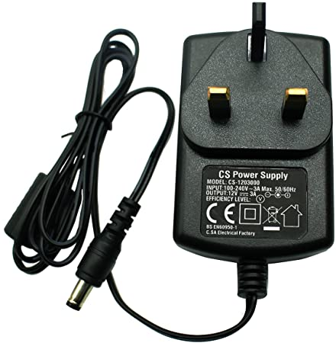

Figure 5.4: 12Vdc- 3A power Adapter

**5.4 Password input device Selection**

In this system 4x4 touch - keypad will be used to enter password insteady of using push buttons

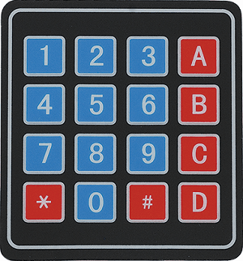

Figure 5.4: 4x4 touch keypard

**5.5 Display unit Selection**

There are varies displays have been designed for different applications. In order to choose the suitable display for this project the qualitative analysis has to be done. Table 5:7 below represents different displays and their characteristics.

**Table 5.3** Different types of displays and their characteristics

|  |  |  |  |  |
| --- | --- | --- | --- | --- |
| **Characteristics** | **Seven segments** | **LCD display** | **LCD bar graph** | **Matrix** |
| Operating voltage (V) | 2-5 | 4.5-5.5 | 5 | 5 |
| Cost | Low | Low | Moderate | High |
| Display capability | Display only numbers | It displays alphanumeric | It displays graphs | It displays alphanumeric by multiple dot |
| Dimension | 1x1 | 16x2, 20x4 | 16x2 | Variable dimension |

**From the table 5.3 above the LCD display is chosen as it meets all the basic requirements of display unit**

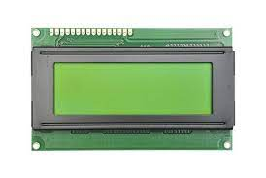

Figure 5.5. Liquid Crystal Display

CHAPTER SIX

CONCLUSION AND RECOMMENDATIONS

**6.1 Conclusion**

All potential data needed for the design of the project was successful collected and were analyzed accordingly. The results were obtained in a way that meets the performance conditions of the circuit, which indicated that the prototype might work under the same conditions; eventually the simulation for this project has been successfully tested and met the objectives of the project. The prototype also has been already built and tested and met all of the objectives set for this project.

**6.2 Recommendations**

This project is very useful; therefore, it must be taken into consideration that TANESCO must install this system in order to eradicate all of the problems caused by the existing system and improve the service which will result in increase of company revenues.

# REFERENCES

[1] R. Hariprakash, G. Venkatramu, S. Ananthi, “University of Madras, K. Padmanahan “Some Problem and Methods for Remotely Controllable Automatic Home Security System” Systems and Networks Communications. ICSNC, 3rd International Conference Publication, ISBN: 9780-76953371-1, (2008) 400-403

[2] S. Tanwar, P. Patel, K. Patel, S. Tyagi, N. Kumar, M. S. Obaidat, ‘An Advanced Internet of Thing Based Security Alert System For Smart Home’. India : May 2017

[3]. Sayidul Morsalin, A. M. Jahirul Islam, Golam R. Rahat, Syed R. H. Pidim,Abdur Rahman, Md A. B. Siddiqe, ‘Machine-To-Machine Communication Based Smart Home Security System By Pir Sensor With Mobile Android Application’. India :2016